Menu - HOME - BAI EVENTS – About Us – Contact

HOME

Welcome to Bengali Association of Indiana

From BAI Family

News Highlights

**Welcome new committee (2023-27)**

* *President: Nandita Das*
* *Vice-President: Sonali Chanda*
* *Treasurer: Abhijit Das*
* *Secretaries: Sudip Biswas, Kamalika Chatterjee*

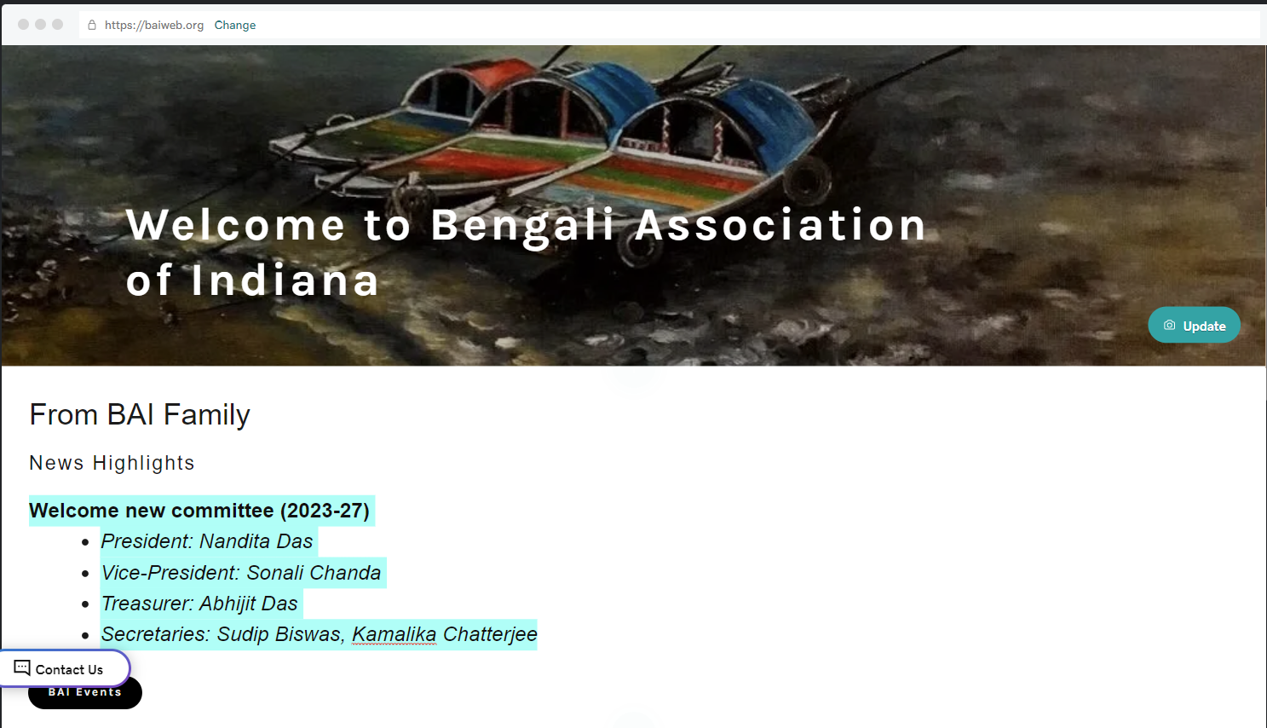

About Us

The Bengali Association of Indiana (BAI) is a non-profit socio-cultural organization. The main objectives of BAI are to engage in educational, cultural, and religious celebrations of Bengal and the Indian subcontinent. We foster the spirit of friendship and cooperation among our members and local and global communities. The membership is open to all who believe in the objectives of the BAI, irrespective of race, religion, color, gender, age or national origin.

Our Executive Committee

Asim De, Anirban Banerjee, Sourav Saha

Poulomi Ghosh, Tuhina Chakrabarti, Purvi Merhotra,

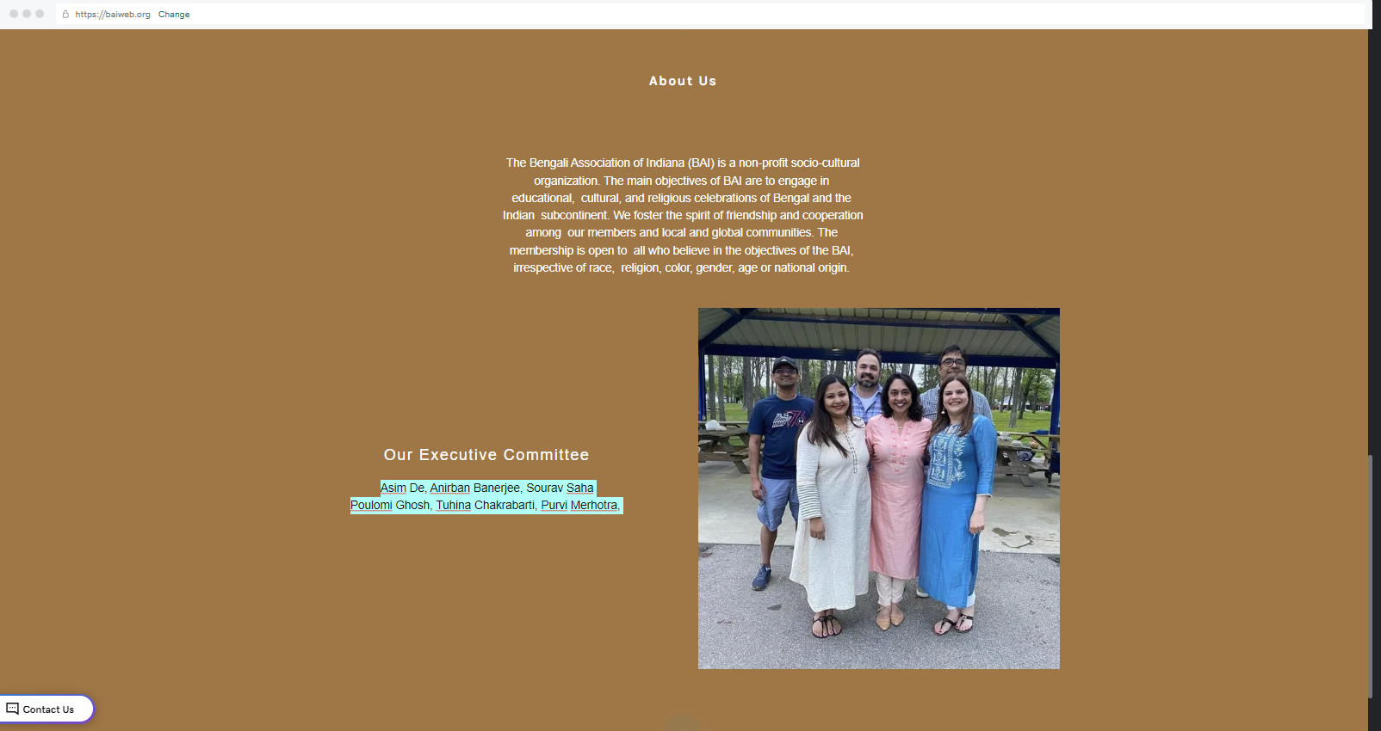

**BAI By Laws**

[Download PDF](https://img1.wsimg.com/blobby/go/fbce3796-a27d-43e8-b587-4d012b86f90c/By-laws%20of%20Bengali%20Association%20of%20%20Indiana%20-%20M.pdf)



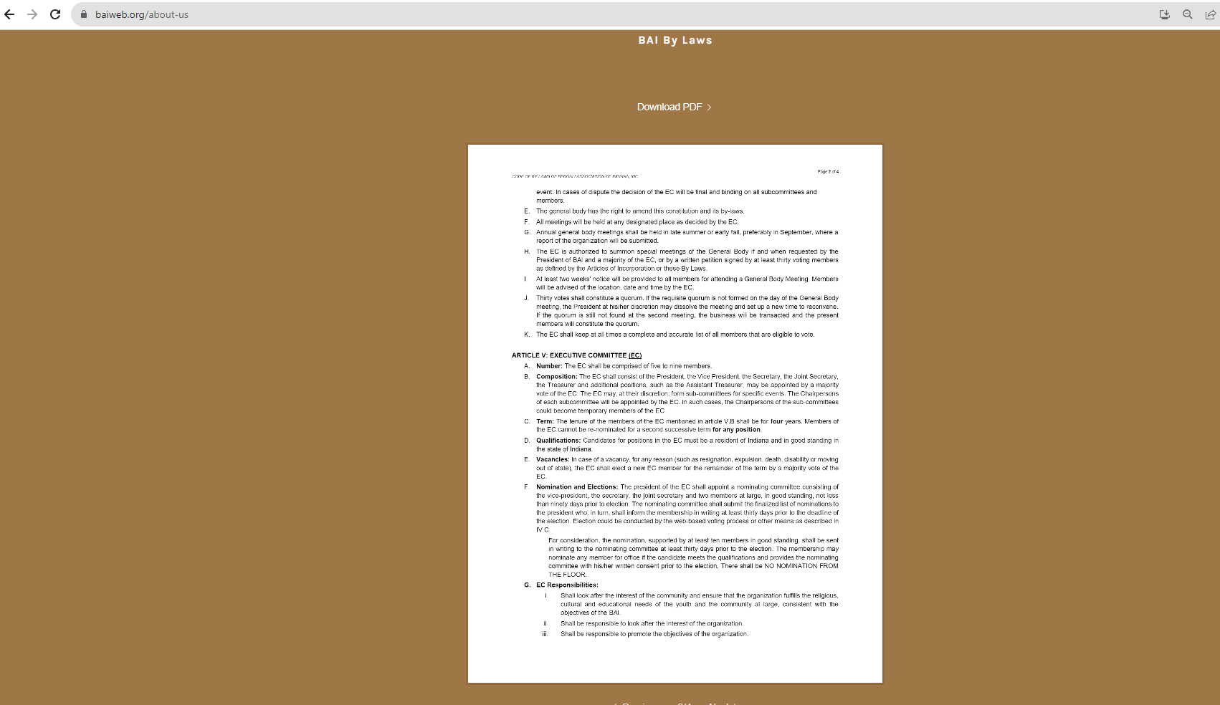

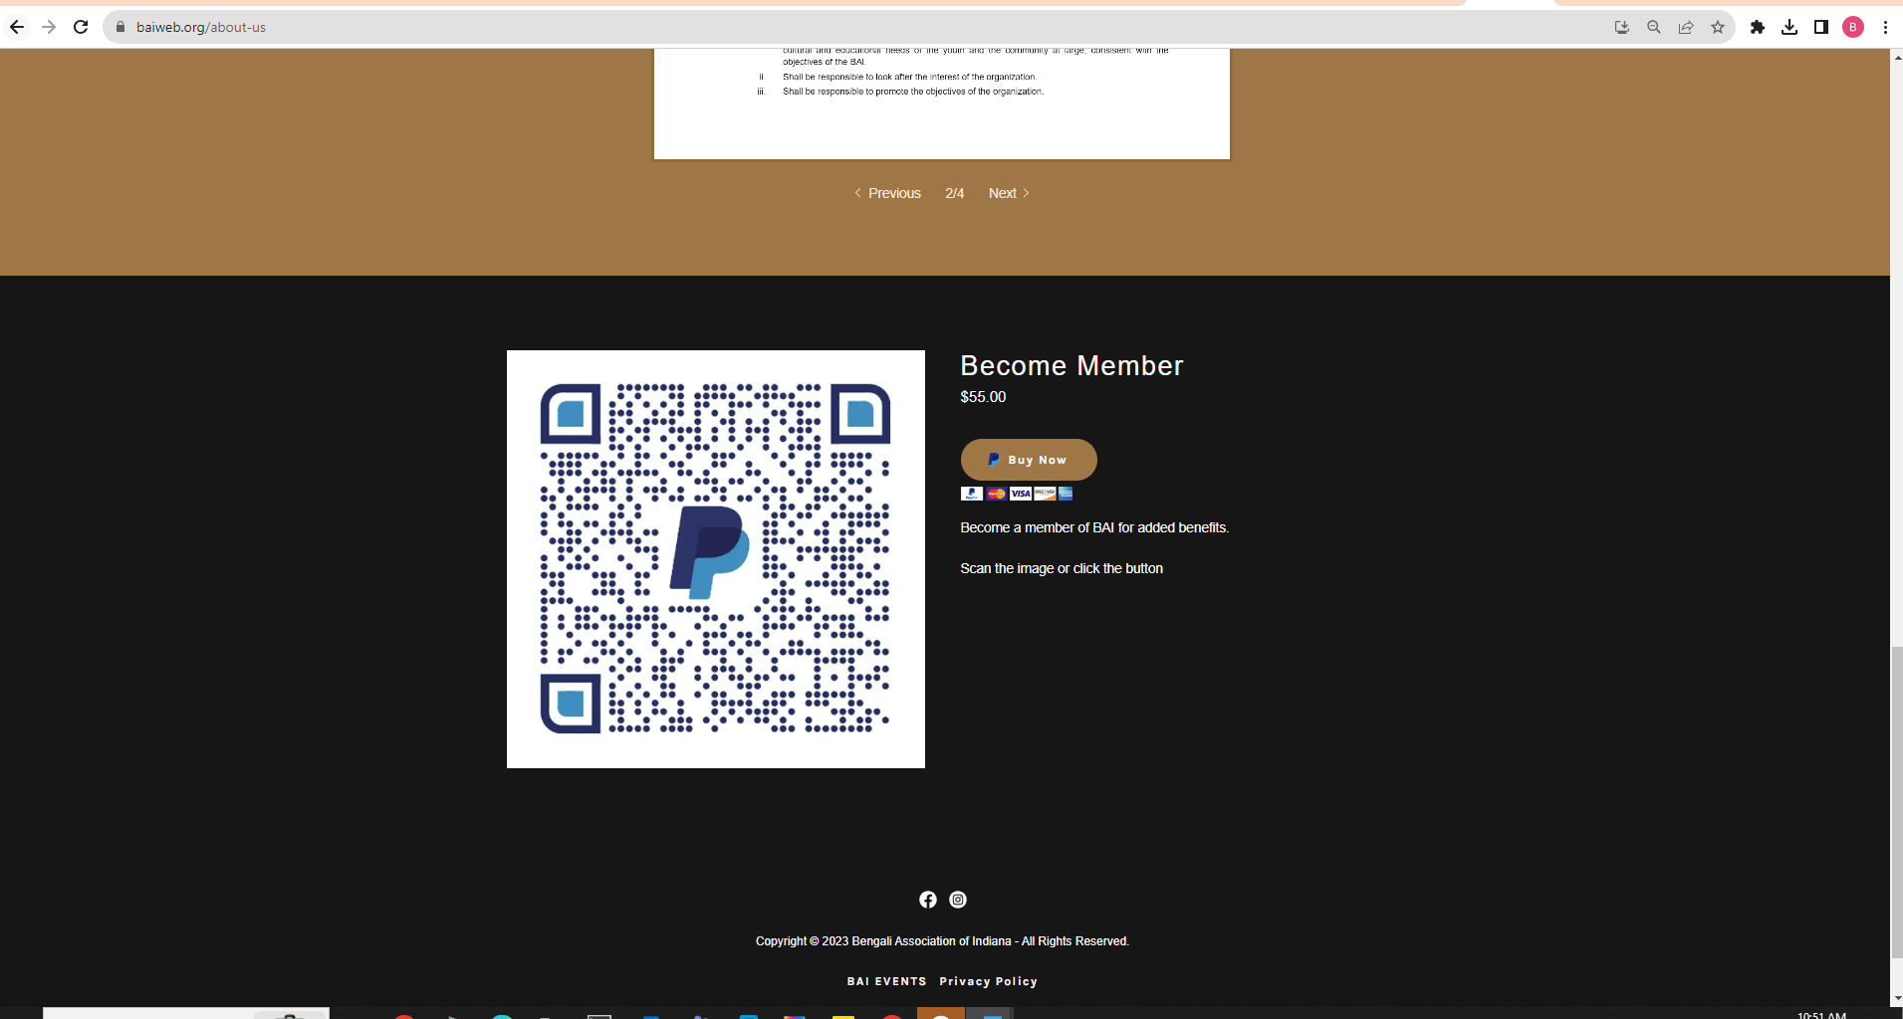



### **Become Member**

$55.00

Top of Form

Buy Now

Bottom of Form

Pay with PayPal or a debit/credit card

Become a member of BAI for added benefits.

Scan the image or click the button

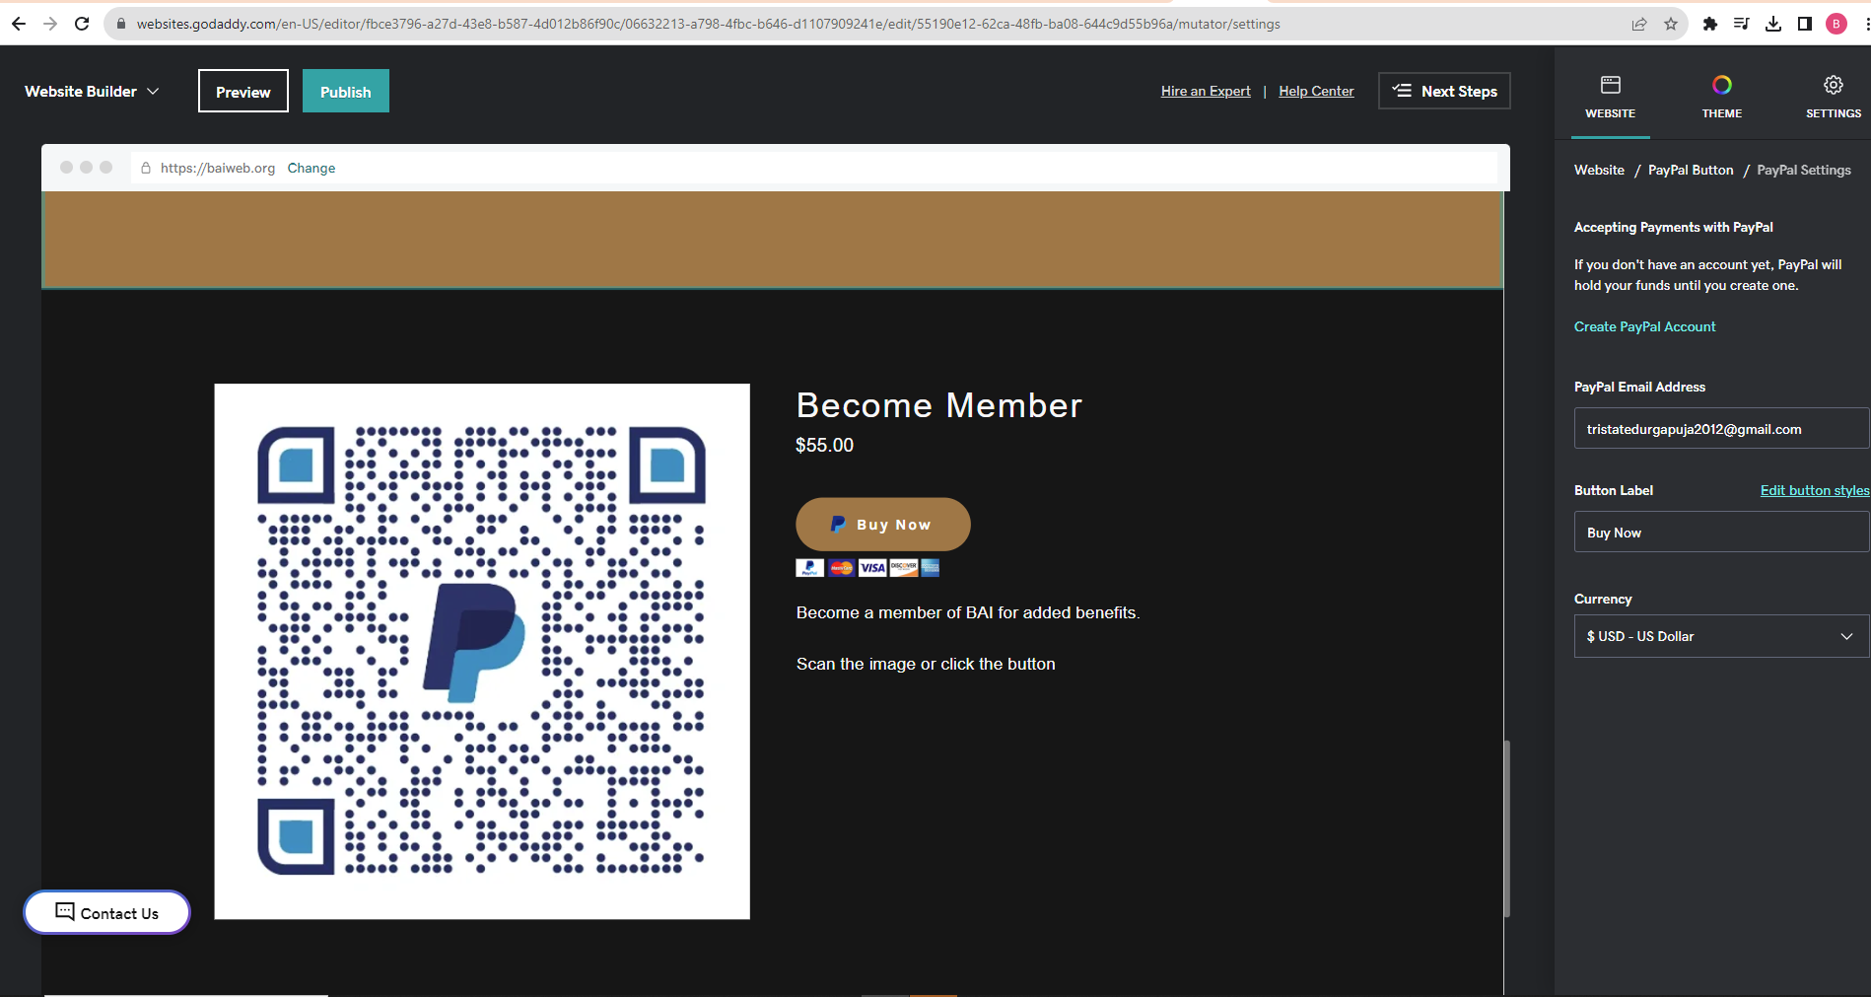

Contact Us

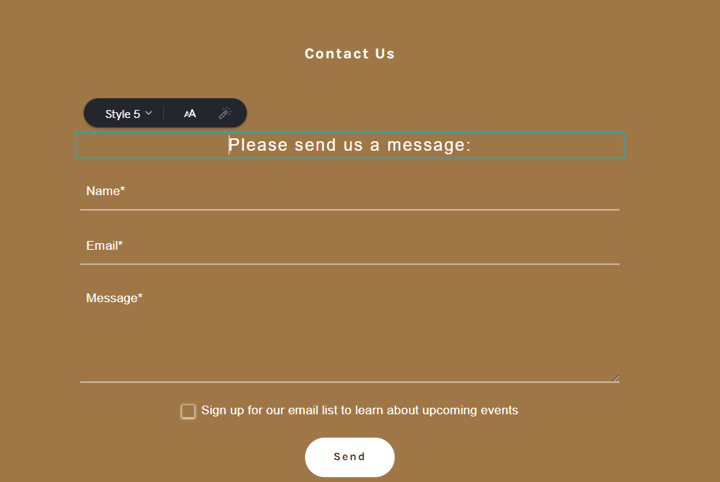

FOOTER



Copyright © 2023 Bengali Association of Indiana - All Rights Reserved.

* [**BAI EVENTS**](https://baiweb.org/bai-events)
* [**Privacy Policy**](https://baiweb.org/privacy-policy)

Contact us at ec@baiweb.org

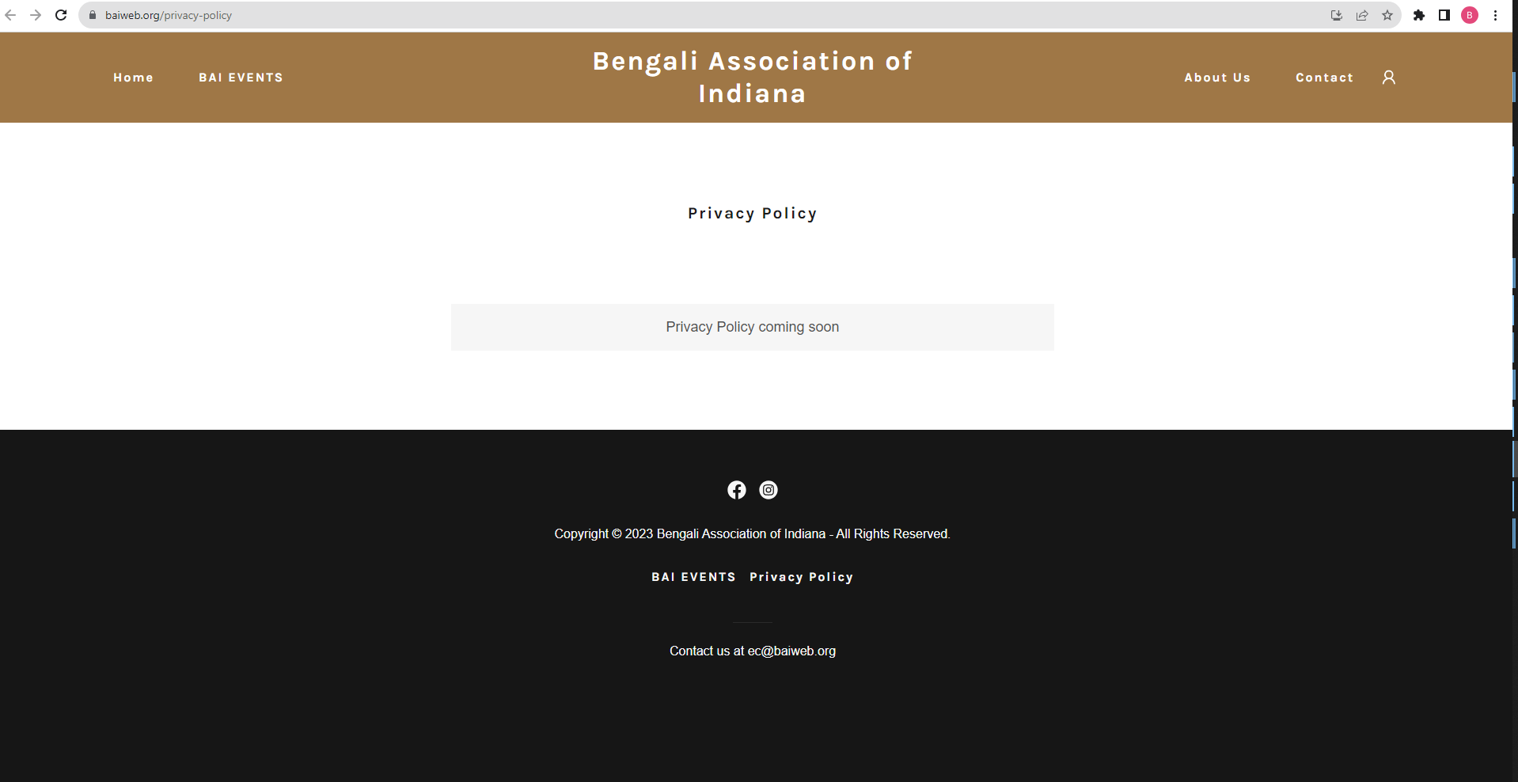

**EXTRA PAGES –**

BAI 2023 Executive Committee Elections

We want to hear from you.....

* You are asked to nominate

§ The candidate for President specifically

§ The rest of the EC members (VP, Treasurer, Secretaries)

* This survey page will be available for the month of February 2023

Rules of Voting

* **You are allowed to self-nominate yourself if you choose to do so.**
* **Please do not pick anyone from current EC or their immediate family members**
* **Please refrain from sending multiple responses**

(This will invalidate your nomination)

The Election Commission for this year can be reached by clicking the button on left if you have any questions regarding this process.

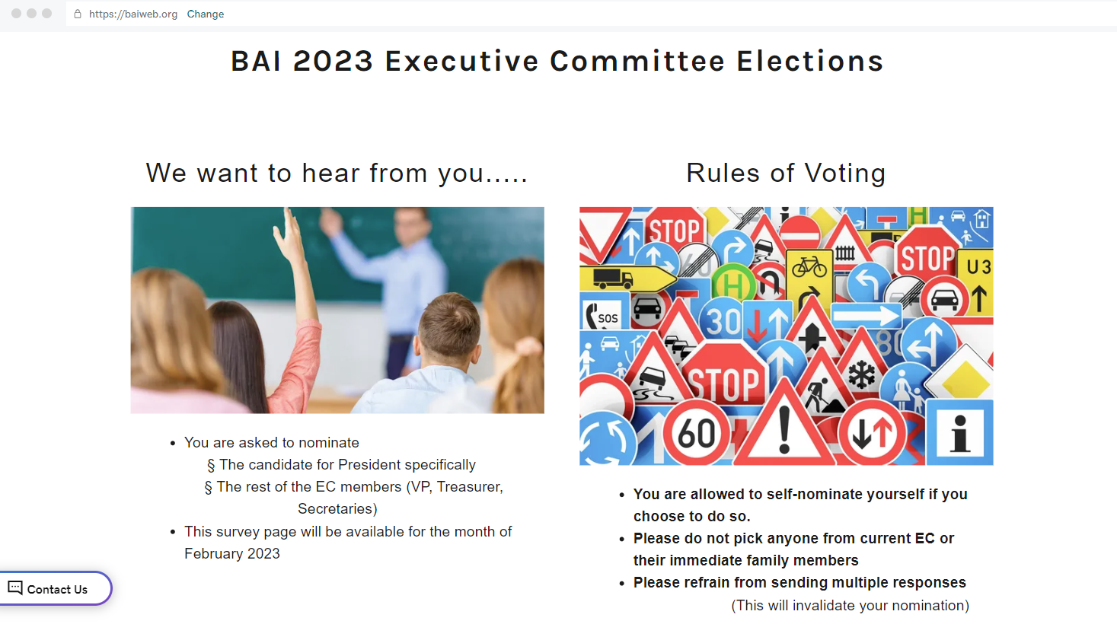

Your Opinion

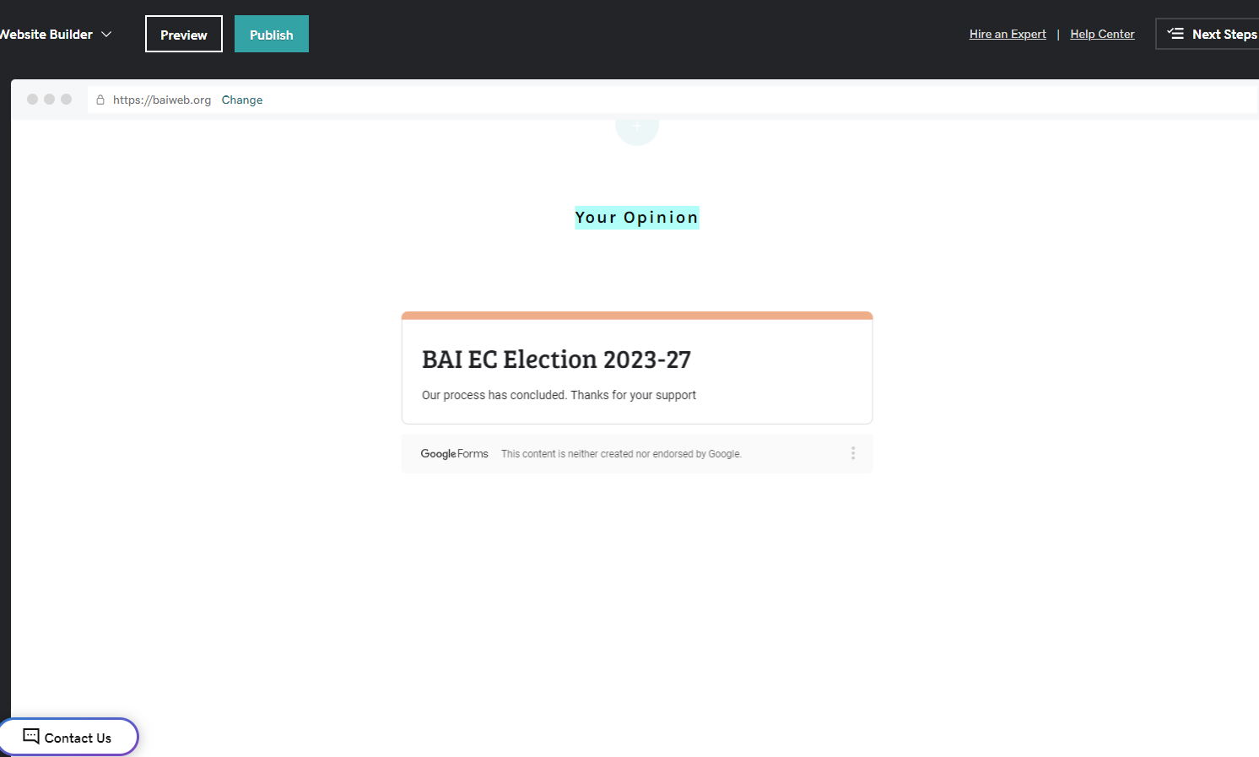

Durga Puja 2021



General Information

Registration Information

Registration is closed. To access your registration details, click [here](https://tsdpregistration.azurewebsites.net/) (you will be redirected to an external site)

**\*\*No on-site registration will be available\*\***

**Contact indanasharodutsav@gmail.com for any questions**

When

October 16-17, 2021

Where

[The Silver Centre Event Hall](https://www.google.com/maps/place/The+Silver+Centre+Event+Hall/@39.780265,-85.9874675,18.58z/data=!4m13!1m7!3m6!1s0x886b48e5e5eb3ee1:0x5b0f5b3224e7e8a2!2s10202+E+Washington+St,+Indianapolis,+IN+46229!3b1!8m2!3d39.7793886!4d-85.98632!3m4!1s0x886b4bae22ef3157:0xbcf14d21fb2517c1!8m2!3d39.7808548!4d-85.9875318)

10202 E Washington St.

Suite 300

Indianapolis, IN 46229

On Social Media

For the most up-to-date information, see the Tri-State Durga Puja 2021 Facebook page [here](https://www.facebook.com/tsdp2021).

Covid 19 Precautions

A description of Covid 19 precautions can be found [here](/tsdp-2021-covid-19-1).

Schedule

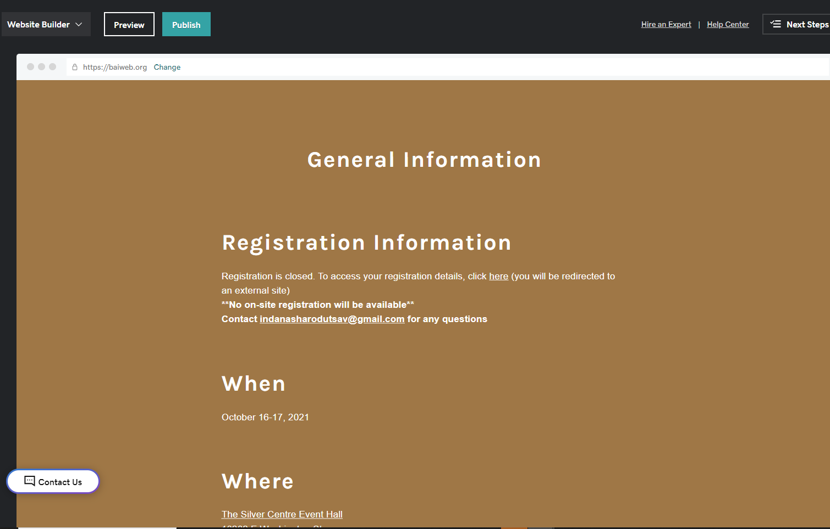

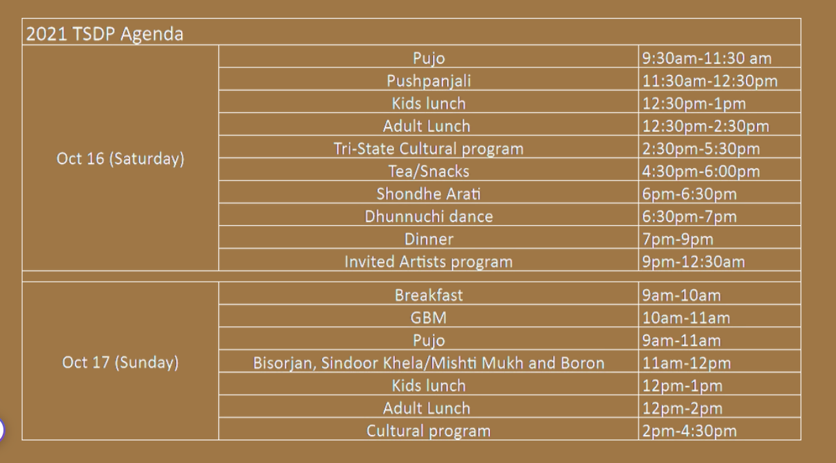

Cultural Program

A few have expressed concern in having a cultural program in the pandemic situation. We realize that the pandemic has had a devastating impact on all our lives. Many lives have been lost and members of our own community have been adversely affected. Therefore, while organizing the pujo this year we are keeping this in mind, and planning to have an event that is positive in spirit, while at the same time being mindful of the pandemic and its impact on our lives. The performing artists were also impacted during this time and we are happy to be able to support them by inviting them to perform.

The details regarding the TSDP cultural program for Saturday evening and Sunday afternoon are as follows:

Saturday October 16:

* Bolpur to Bombay: A magical journey through music of Bengal, Bollywood and Beyond by the talent duo of Sharmistha and Subrata Kolay.
* Following Bolpur to Bombay, we will have a scintillating performance by **Indian Raga** (https://indianraga.com/)

Sunday October17:

* Melodious Rendition of Rabindra Sangeet by Kamalini Mukherjee

Hotels

The following hotels are available near the venue: [**Indianapolis Marriott East**](https://www.marriott.com/event-reservations/reservation-link.mi?id=1628774768636&key=GRP&app=resvlink) (Bengali Association of Indiana has blocked a set of rooms at a discounted rate, please book using the link above) [**Delta Hotels by Marriott, Indianapolis East**](https://www.marriott.com/hotels/travel/inded-delta-hotels-indianapolis-east/) [**Fairfield Inn & Suites by Marriott Indianapolis East**](https://www.marriott.com/hotels/hotel-rooms/indes-fairfield-inn-and-suites-indianapolis-east/) [**Holiday Inn Express & Suites, Indianapolis – East**](https://www.hiexpress.com/redirect?path=rates&brandCode=EX&localeCode=en&regionCode=1&hotelCode=INDEE&checkInDate=15&checkInMonthYear=092021&checkOutDate=17&checkOutMonthYear=092021&_PMID=99801505&GPC=BAI&cn=no&viewfullsite=true) (A block of 20 rooms has also been reserved here at a discounted rate. Follow the link above or use group code BAI)

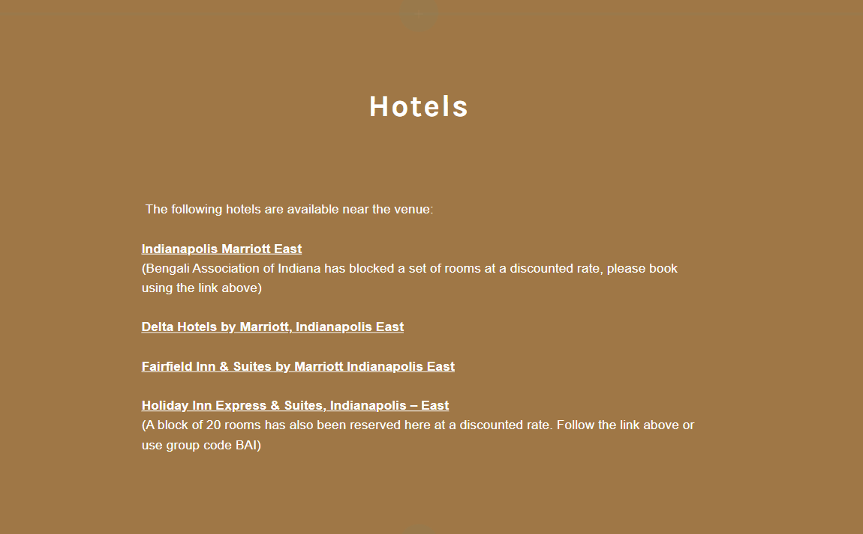

Committees

|  |  |  |
| --- | --- | --- |
| Fundraising Committee | Decoration Committee | Kids Committee |
| **Chair:** Anushree M Bag  **Co Chair:** Arnab Bag  Kalyani Bose  Madhurima Banerjee  Sonali Majumdar  Soumi Mukhopadhyay  Sujoy Deb | **Chair:** Nandita Ganguli  **Co Chair:** Sonali Chanda  Nabomita Kundu  Debamita Banerjee | **Chair:** Moumita Kar  Anindita Barman  Parama Paul  Sutapa Banerjee  Hrishit Dutta  Nairit Dutta |
| Puja Committee | Operation committee | Food Committee |
| **Chair:** Prachi Chatterjee  Minakshi Basu  Monisha Chatterjee  Madhurima Moulik  Ena Bhattacharya  Radhika Sinha  Payal Banerjee  Lopamudra Chakravarty  Sanchari Biswas | Arup Roy | **Chair:** Kalyani Bose  **Co chair:** Subir Chakrabarti  Sudip Das  Dhiman Chatterjee  Sonali Chanda  Paroma Bose  Arijit Bhowmick  Debabrata Dutta  Eamon Mukhopadhyay  Radhika Chatterjee  Oindrila Bhattacharya  Rashmita Basu  Nayanika Mukherjee  Madhurima Banerjee  Debashree Sinha |
| Registration Committee | Logistics Committee | Cultural Committee |
| **Chair:** Dhiman Chatterjee  **Co Chair:** Renuka Chatterjee  Reid Erekson  Sudip Biswas  Radhika Chatterjee  Sukanta Majumdar  Esha Hrivnak  Ray Sood | **Chair:** Debabrata Dutta  Aninda Kar  Sujoy Deb  Arijit Bhowmick | **Chair:** Soumi Mukhopadhyay  **Co chair:** Kuhely Dey  Anindita Sen  Madhurima Moulik  Kamalika Chatterjee  Madhubanti Dutta  Nandini Bhowmick  Debarati Bardhan Akala  Haimanti Dutta  Mousumi Mukhopadhyay  Amitava Das |
| Brochure Committee | Cafeteria Decoration Committee | Executive Committee |
| Prithwiraj Ghosh | Mousumi Mukhopadhyay  Anisha Erekson  Paroma Bose | Tuhina Chakrabarti  Asim Dey  Sourav Saha  Anirban Banerjee  Purvi Mehrotra  Poulami Ghosh |
|  |  |  |

Our Corporate Partners



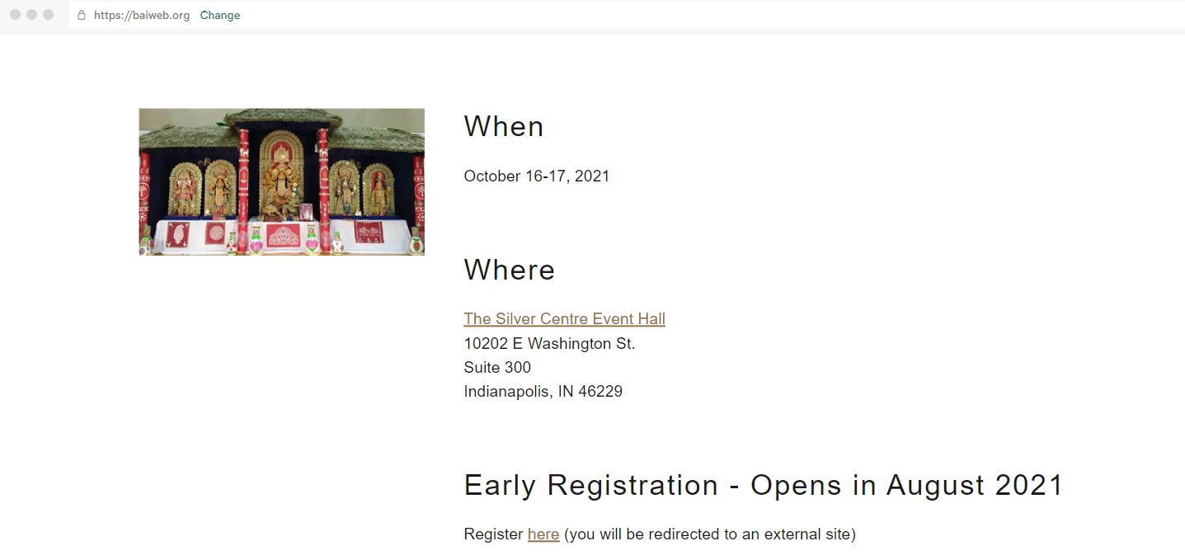

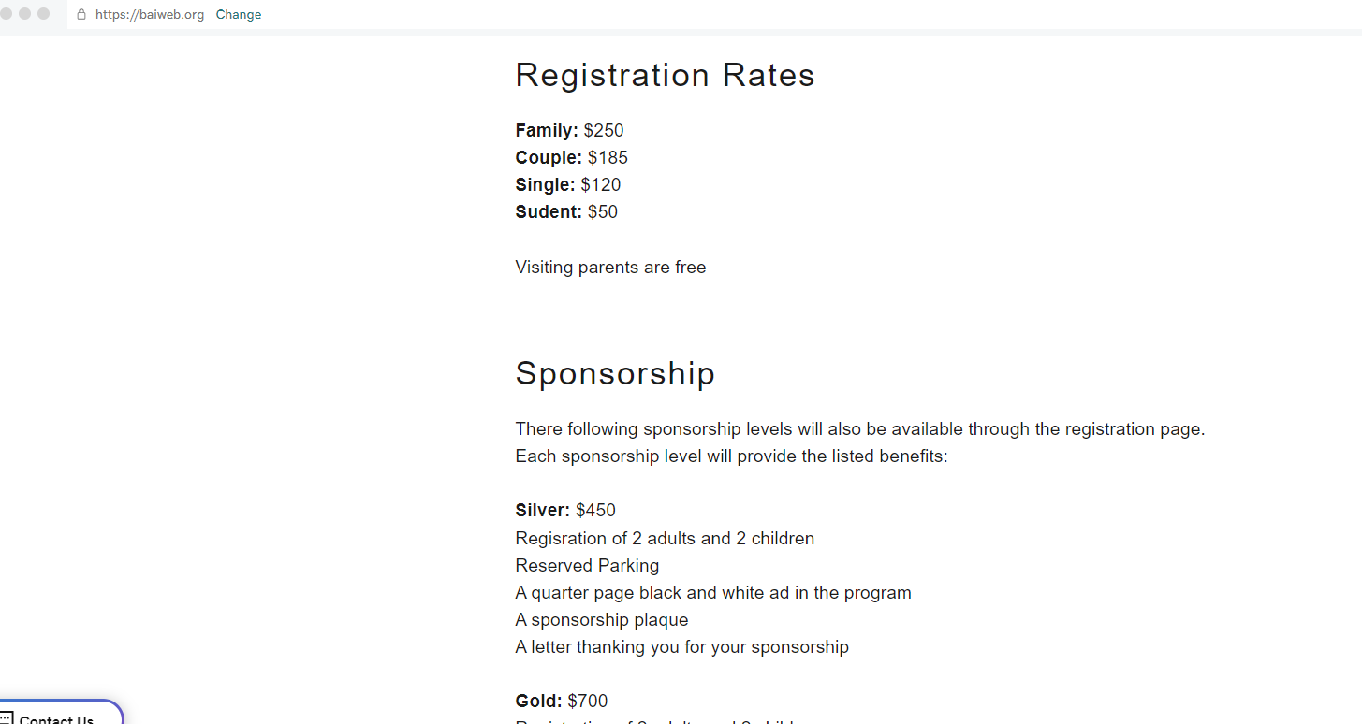

There following sponsorship levels will also be available through the registration page. Each sponsorship level will provide the listed benefits:

**Silver:** $450

Regisration of 2 adults and 2 children

Reserved Parking

A quarter page black and white ad in the program

A sponsorship plaque

A letter thanking you for your sponsorship

**Gold:** $700

Registration of 2 adults and 2 children

Reserved parking

A half page black and white ad in the program

A sponsorship plaque

A letter thanking you for your sponsorship

**Diamond:** $850

Registration of 4 adults and 2 children

Reserved parking

Reserved seating during the evening cultural program

A half page color ad in the program

A sponsorship plaque

A letter thanking you for your sponsorship

**Platinum:** $1200

Registration of 4 adults and 2 children

Reserved parking

Reserved seating during the evening cultural program

A full page color ad in the program

A sponsorship plaque

A letter thanking you for your sponsorship

A surprise thank-you gift

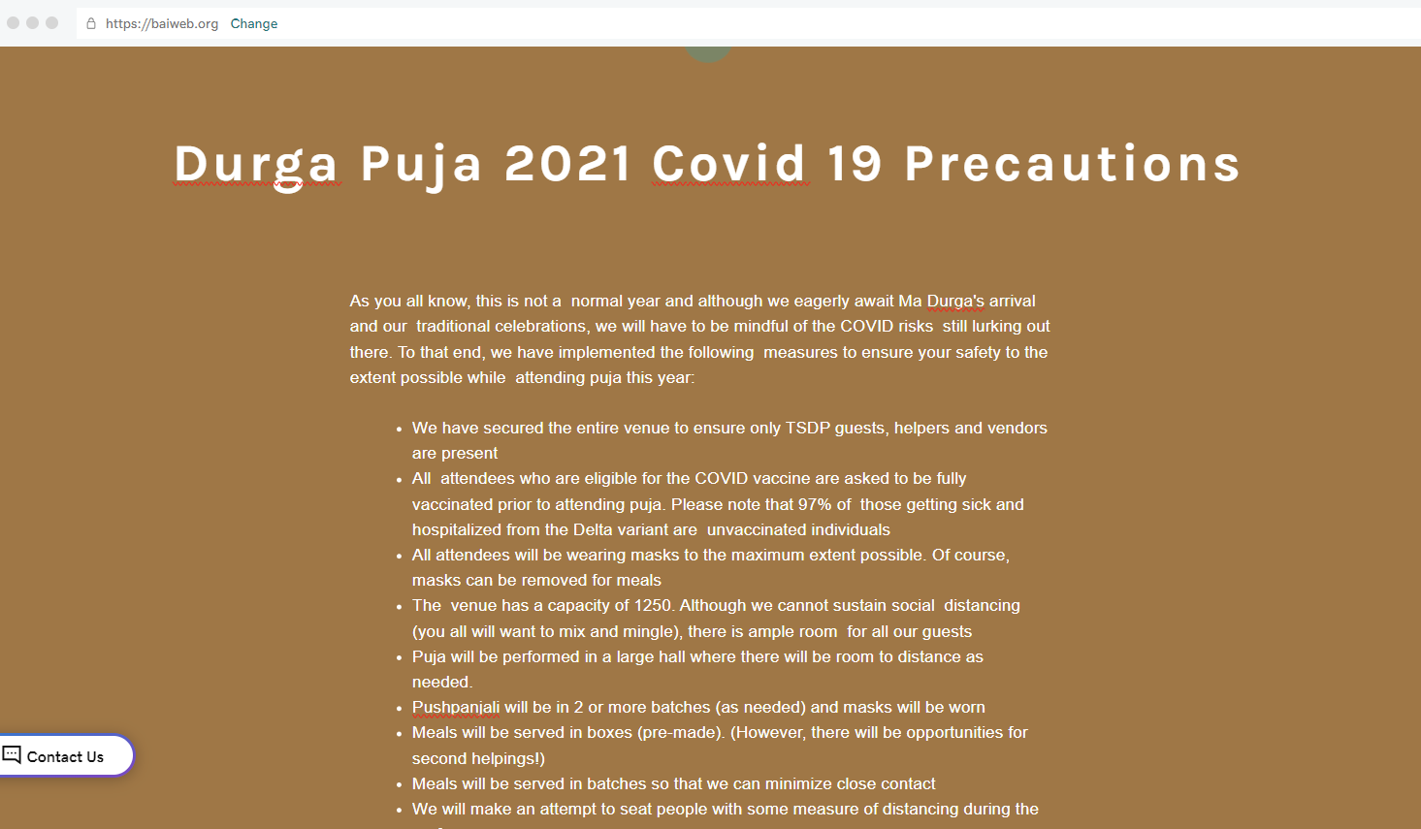

Durga Puja 2021 Covid 19 Precautions

As you all know, this is not a normal year and although we eagerly await Ma Durga's arrival and our traditional celebrations, we will have to be mindful of the COVID risks still lurking out there. To that end, we have implemented the following measures to ensure your safety to the extent possible while attending puja this year:

* We have secured the entire venue to ensure only TSDP guests, helpers and vendors are present
* All attendees who are eligible for the COVID vaccine are asked to be fully vaccinated prior to attending puja. Please note that 97% of those getting sick and hospitalized from the Delta variant are unvaccinated individuals
* All attendees will be wearing masks to the maximum extent possible. Of course, masks can be removed for meals
* The venue has a capacity of 1250. Although we cannot sustain social distancing (you all will want to mix and mingle), there is ample room for all our guests
* Puja will be performed in a large hall where there will be room to distance as needed.
* Pushpanjali will be in 2 or more batches (as needed) and masks will be worn
* Meals will be served in boxes (pre-made). (However, there will be opportunities for second helpings!)
* Meals will be served in batches so that we can minimize close contact
* We will make an attempt to seat people with some measure of distancing during the performances
* We will have multiple hand sanitizing stations and masks available
* A separate large children's activity room has been designated. Kids will be required to wear masks to ensure their own safety
* Sindur Khela on Sunday will be outdoors (we will try to set up a large tent) to ensure safety and minimize any stains. We will have wipes on hand for the ladies who wish to participate.

Please note that although we are striving to create a safe environment, it is up to the guests to make sure protocol is followed.

